A world free from violence, abuse and exploitation by building strong families whose members:

- exemplify spiritual values and beliefs,
- are committed to support each other for their development;
- are capable of solving their problems and meeting their needs, and
- are actively participating in community development activities.

VISION
MISSION

To provide a package of social work interventions and other services to children, women, families, including indigenous people, older and differently-abled persons and victims of calamities needing special protection, care and rehabilitation, as well as depressed communities, by building their capability to uphold their rights become self propelling, self sustaining and self reliant.

Registration:

- Securities and Exchange Commission (SEC)
- Bureau of Internal Revenue as Tax Exempt organization
- Department of Social Welfare & Development
- ( DSWD) Region VII

Accreditation:

- Municipal Government of Cordova
- Cebu City Government
- Regional Development Council (Development Administration Committee- one of the four standing Committees of the RDC)

TASKS AND OBJECTIVES

To promote and strengthen the general welfare of abandoned, neglected, abused and exploited children and youth in a family atmosphere at the CHILDREN’S HAVEN, A RESIDENTIAL HOME FOR CHILDREN AND YOUTH.

To provide both short and long term care, support, security, education, spiritual and other aspects of development to children and youth, to include life skills, formal education from Day Care to college daily comprehensive and integrated social welfare and development programs and services for the senior citizens, for differently - abled persons, women, indigenous people and victims of calamities and families in depressed communities.To acquire through purchase or donation real estate properties, building or equipment to be used solely for the implementation of programs and services.

To provide capability-building, training and consultancy services to implementors of social welfare and development programs of local government units, NGOs & Pos especially on publish and disseminate information about social welfare and development programs to improve the practice of social and service delivery.

To accept or solicit donations (from both foreign and local sources) in cash or in kind, like appliances, equipment, machineries, shoes / slippers, clothing, food supplies and medicine for the various clients it will be serving or referred by local government, the DSWD and other agencies.
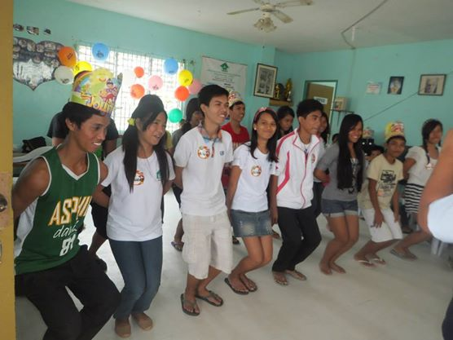
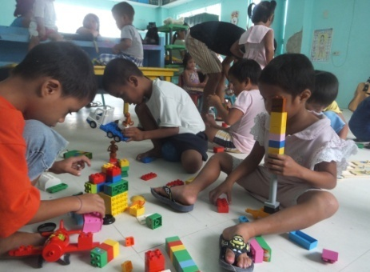

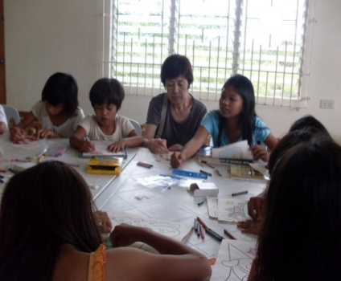
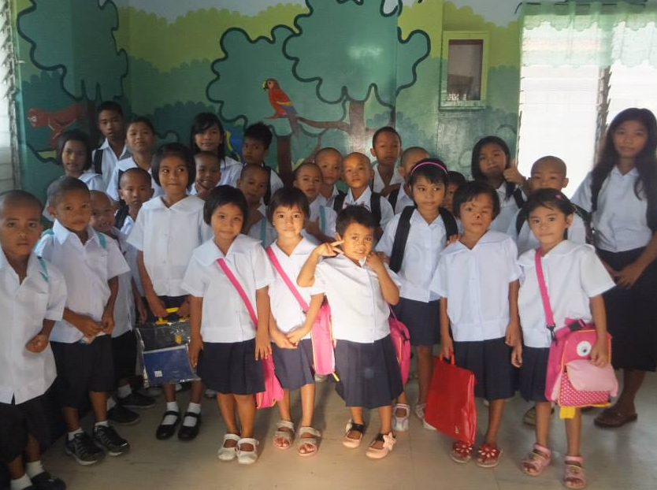

BRIEF HISTORY

ASFFPI was formally organized on January 11, 1997 and registered with the Securities and Exchange Commission on March 20, 1997.

The first Foster Home (Shelter for Children) was built in 1997 serving eight (8) children. Now (2014) ASFFPI has five buildings in Sitio Tugbungan, Pilipog, Cordova, Cebu, after the foundation moved to its present location with 72 children and youth under the care and custody of its Children’s Haven. The lot it occupies is allocated by the municipal government USUCFRUCT Agreement with the foundation. (For more details, pls. visit our website.)

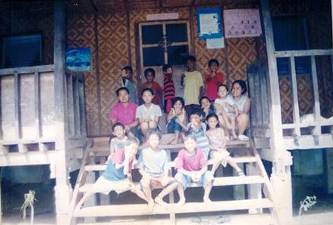
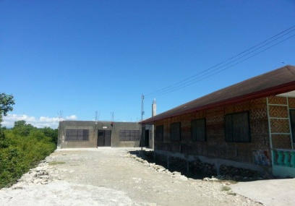
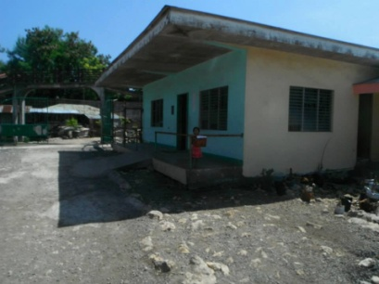
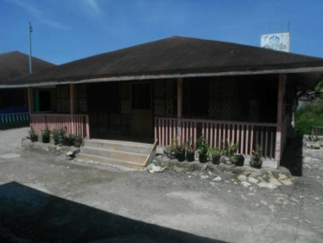

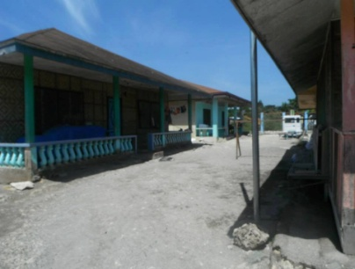
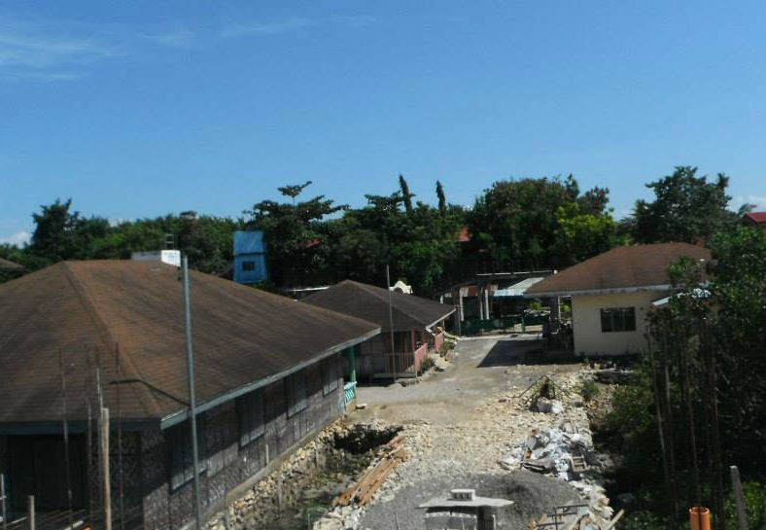

How Can You HELP?

- DONATION
You can donate cash or in kind. Cash donation could be deposit to Union Bank Mango Avenue, Cebu City or any Union Banks branches.
Peso Checking Account No.
502-030-00159-8
Dollar Checking Account No.
132760002715

- SPONSOR A CHILD
- College -P5,000.00/month
- High School -P2,500.00/month
- Elementary -p1,500.00/month

- VOLUNTEER
Volunteers are requested to contribute $17 per day for accommodation, simple meals and use of internet, printers and photo copier. Volunteers’ work depends on their expertise and skills. (Please see our webpage for details)

- INTERNSHIP
Social Work Students or BS Education Students required their school to acquire 1,000 hours of internship are accepted.
Foreign students could also be accepted.

For details, Kindly contact us thru:

Email: asffpi_cebu@yahoo.com
Telephone No.: (006332) 469-7608 and look for:

Mrs. Martiniana D. Mercado, R.S.W
Executive Director
Email: martycdo@yahoo.com
Mobile Phone No.:0906-457-8731
0928-403-8695

Mrs. Ligaya V. Maquiling, R.S.W.
Deputy Executive Director
Mobile Phone No.: 09237445329

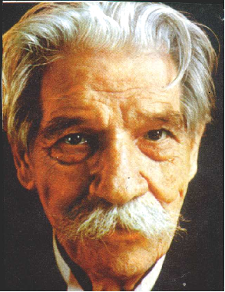“As far as I can look back I suffered from the misery I saw in the world. I did not really know natural young zest for life, and I believe that many children go out as well-even if they appear quite happy and carefree”
(Albert Schweitzer)

Dr. Albert Schweitzer, a theologian, philosopher, musicologist and a doctor of medicine, was born on January 14, 1875 in Kaserberg Alsace, Germany. He spent his boyhood in Gunsback and attended gymnasiums (secondary education) at Mulhcusen, Germany.

He received three degrees at the University of Strasbourge – Doctorate in Philosophy (1899) a licentiate (higher degree than the Doctorate) in Theology (1900) and a Doctor of Medicine (1913). He also received his Honorary Degree in Music.

In 1902 he was appointed curate in Strasbourge and in 1903 he became Head of its Theological College. He gave lectures and published the admirable biography of Johann Sibatian Back in 1905. His quest for the Historical Jesuit (1906) brought him international fame.

Upon reaching 31 years old, he became an eminent theologian, successful teacher and preacher, an organist, leading authority on J.S. Back and in organ construction. He became a medical missionary with one of the most backward tribes in Africa. In 1913, he established a hospital in Lambarene, along the Ogone River in the Gabon Colony of Africa.

He was awarded the Nobel Prize for Peace in 1952 and The British Order of Merit (Honorary) in 1955. He died in Lambarene on September 4, 1965.

Albert Schweitzer Familienwerk Foundation Philippines, Inc. ASFFPI
Website: www.asffpi.webs.com
Telephone No : (006332) 496-7608
Email: asffpi_cebu@yahoo.com

Caring for the underserved sector of our
society is our business
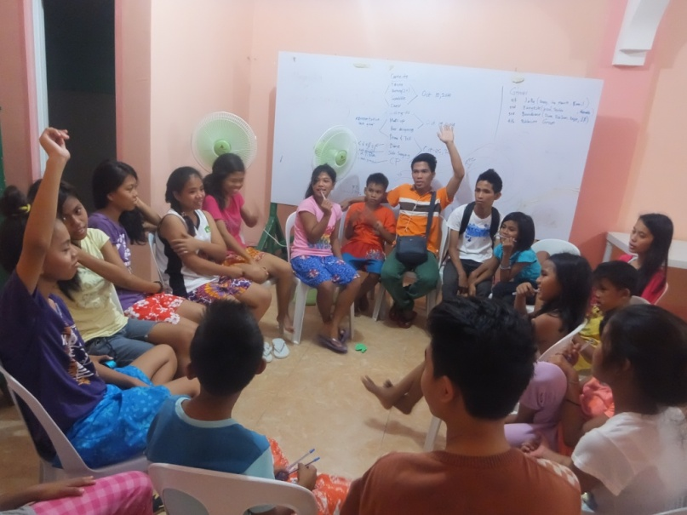

Sitio Tugbungan, Pilipog
Cordova, Cebu 6017 Philippines

Regional Winner
2007 National Search for Outstanding
Volunteer sponsored by PNVSCA

